- Setup a virtual machine using Ubuntu image.
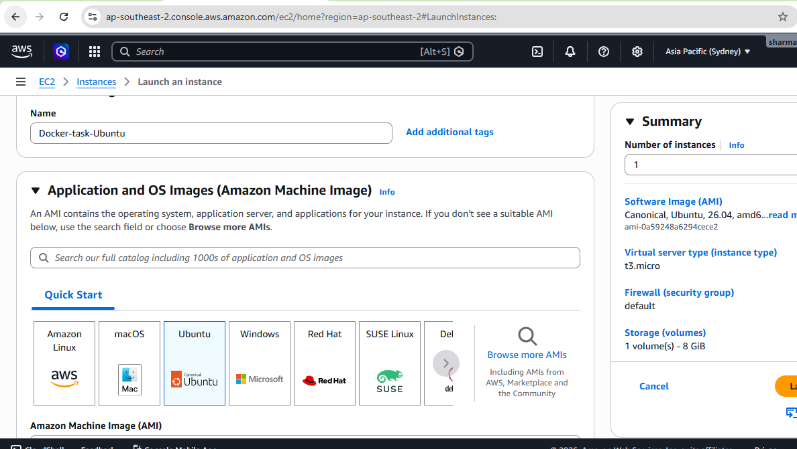
- Install docker on ec2.
Connected to the instance and then installed docker as well:
Update packages: apt update
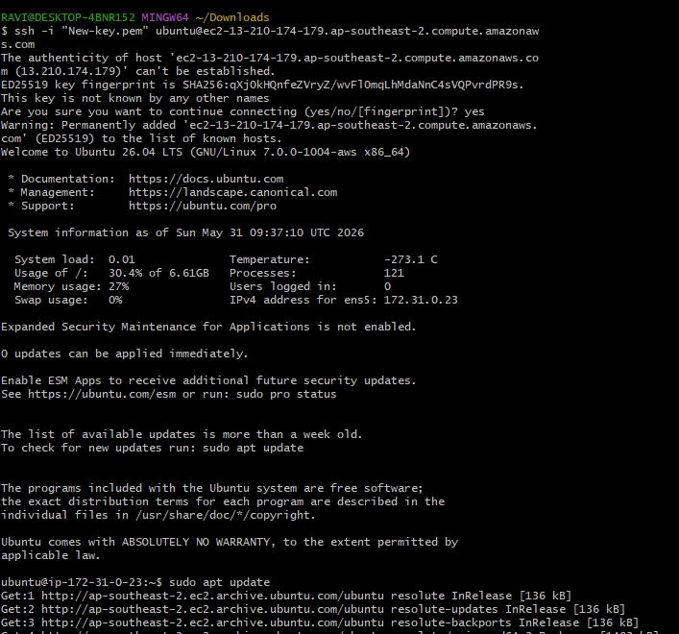
Install Docker: sudo apt install docker.io -y
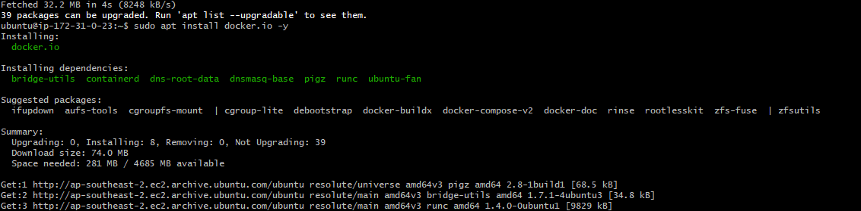
Enable and start Docker:
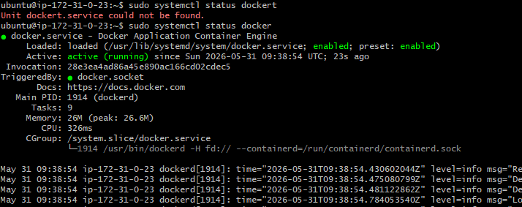
Check Docker version:
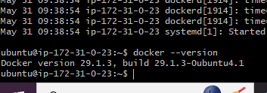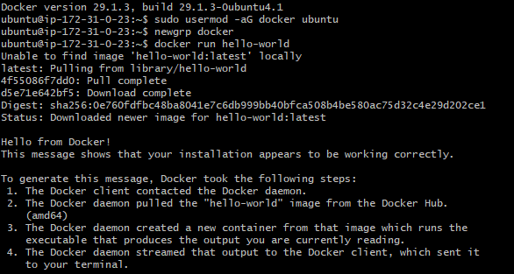
- Pull 5 docker images. (nginx, Apache tomcat, ubuntu, Jenkins, SonarQube)
Pull images one by one:
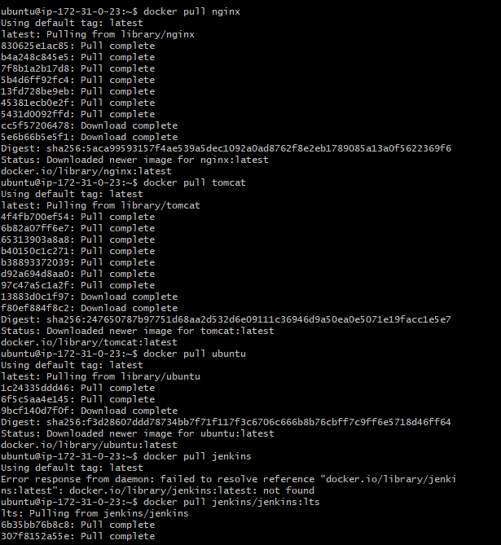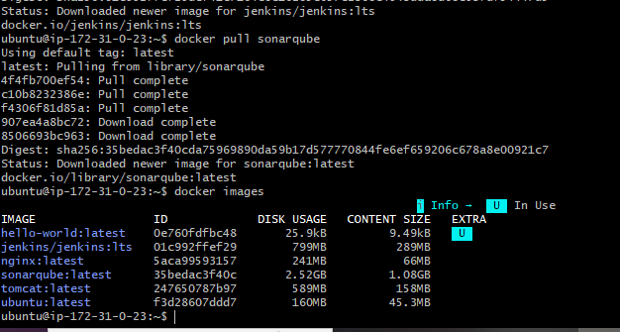
- Run nginx container and expose on port 81.
Run container: docker run -d --name nginx-container -p 81:80 nginx
Check running containers: docker ps
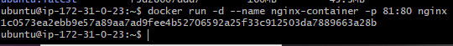
Access in browser:
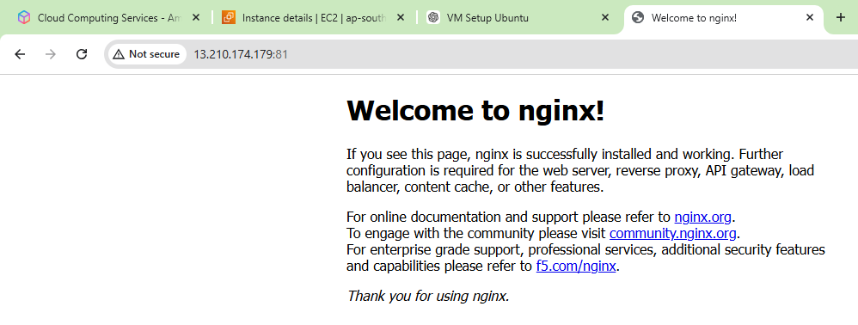
- Delete the Apache tomcat image from local.
Delete Tomcat image: docker rmi tomcat
docker rm -f <container-id>
docker rmi tomcat
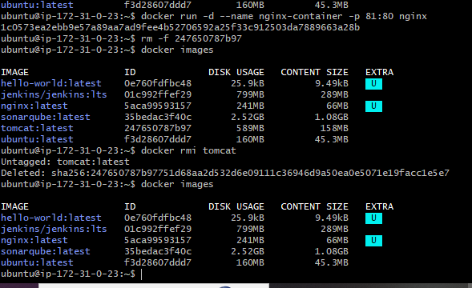
- Inspect the Jenkins image, SonarQube image.
Inspect Jenkins Image : docker inspect jenkins/jenkins:lts
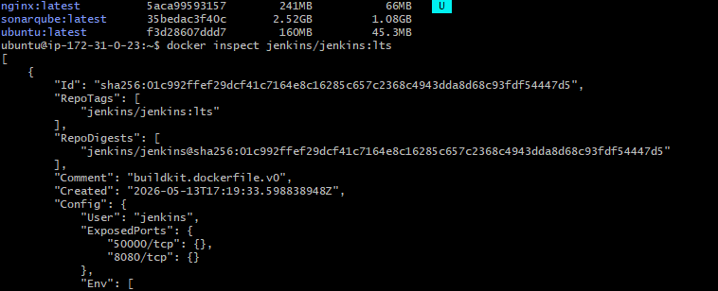
Inspect SonarQube Image : docker inspect sonarqube
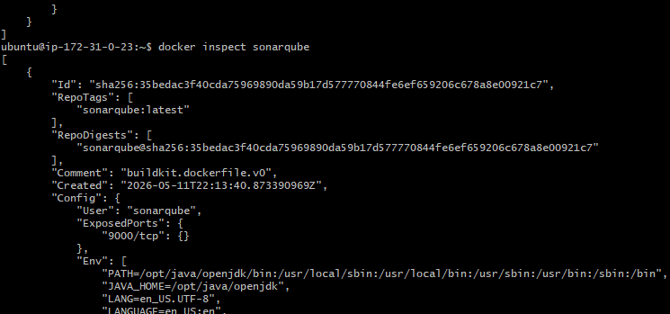
- Run Jenkins container and run one sample job.
Run Jenkins Container
Check container
docker exec jenkins cat /var/jenkins_home/secrets/initialAdminPassword
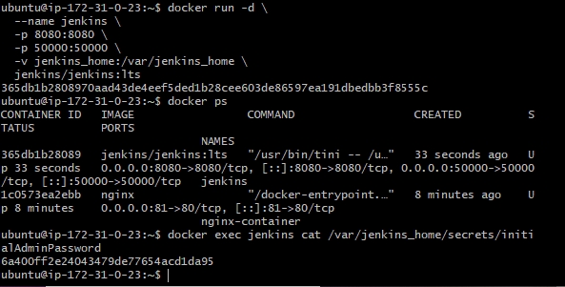 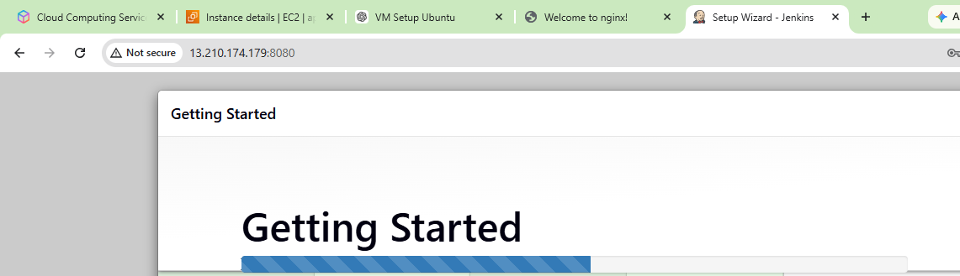
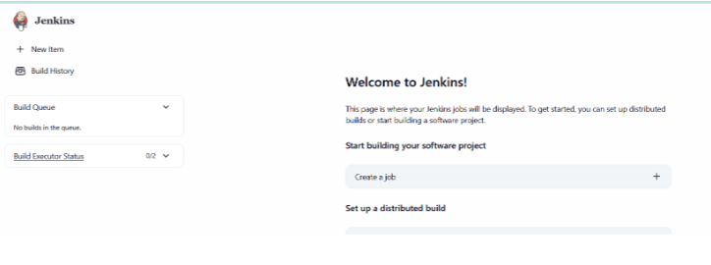
Create Sample Jenkins Job:
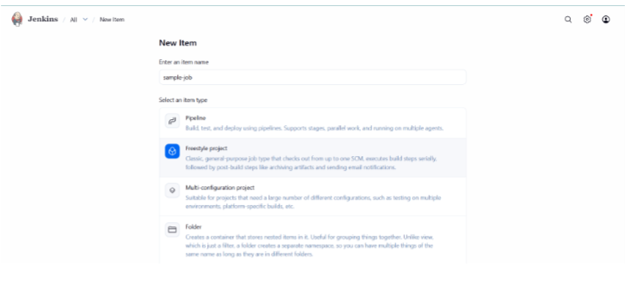
Build step:
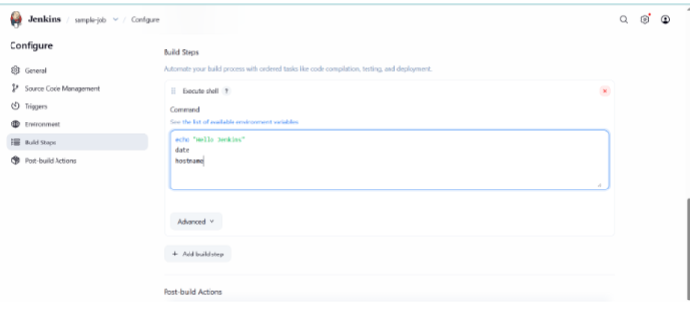
Save & build now
Check the console output:
